Submission Guidelines For FLIPSTER
The information below is intended to outline some common preferred criteria and practices in order to send electronic data to EBSCO Information Services to be used on the Flipster product. These guidelines describe our preferred data formats and deliveries. Following the guidelines outlined below will improve the customer experience as well as processing time and quality. We are happy to review sample files in advance.

PDF LAYOUT SPECIFICATIONS

RequirED:

- PDF delivery must contain the full issue, including front and back covers and advertisements, without placeholders (either as a single issue level PDF or multiple page level PDFs).

PERFERRED:

- Single issue level PDF in the correct sequence.
- The content sequence should match that of the final version.
- PDF should not contain two-page spreads. Each unique page should be its own page in the PDF.
- Each PDF must have a TrimBox and CropBox to ensure proper processing and screen display.
Pages must be cropped and free of “dead-space” and/or printer marks. See Figure 1 for an example.
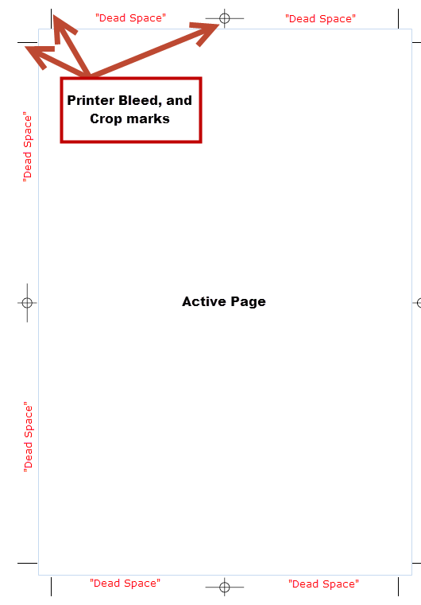 Figure 1: TrimBox and CropBox example

RECOMMENDED:
- Gatefold pages should be presented as individual pages in the order they should be represented.

PDF Format SPECIFICATIONS

Required:
  - PDF 1.3 or later. If created with Adobe Acrobat, Adobe version should be version 4.0 (minimum) or higher.
  - We cannot accept image-only PDFs, i.e., pages that are scanned or for which images are embedded into the PDF.
  - Files should not have encryption, password protection, or any security features applied in Acrobat.

PREFERRED:
- PDF 1.5 or Adobe version 5.0 is recommended.
- We recommend images and artwork at the following resolutions:

 | Optimum | Minimum | Maximum
Line Art (vector) | Leave as original | Optional compression
Color | 150 dpi | Minimum: 72 dpi | Maximum: 300 dpi
Grayscale | 150 dpi | Minimum: 72 dpi | Maximum: 300 dpi
Bitmap | 300 dpi | Minimum: 72 dpi | Maximum: 300 dpi

NAMING ConVENTIONS

PREFERRED:
- The file should be labeled with the magazine name (initials are fine) or ISSN/ISBN, the volume, and the issue separated by an underscore.
- For data files at the article level, each file name should also include page number the article begins on.
- For data files containing only advertisements, the file name should include the page number that preceded the ad followed by letter (a, b, c).
- Please do not include any spaces or special characters in the file name. (Back slashes (\), colons (:), question marks (?), ampersands (&) etc.)

Examples
- For an article beginning on Page 1: 1234-5678_v01_i01_p001.pdf
- For an advertisement appearing after Page 10, and before Page 11: 1234-5678_v01_i01_p010a.pdf

DELIVERY METHODS

REQUIRED:
- If available, an issue publication schedule should be provided in advance to EBSCO to allow for maximum speed to market.
- Full issue must be uploaded at one time. EBSCO cannot support partial uploads.
- FTP-(File Transfer Protocol). This is the best method of data delivery. We recommend using FileZilla for FTP delivery. If you use a different FTP client, please make sure to set it up for UTF-8 compatibility to ensure files are properly received. EBSCO will provide you with a username/ password.
- One-time steps using FileZilla
- Download FileZilla from https://filezilla-project.org/download.php
- There are detailed Tutorials available on the website.
- Install Filezilla
- Open application
- From File Menu select “Site Manager”
- Select “New site” and add create a folder with your ftp username
    - Hostname: ftp.epnet.com
    - Username: To be supplied by EBSCO
    - Password: To be supplied by EBSCO
    - Save your profile
- Go to “Charset” tab and select Force UTF-8 setting as default, see Figure 2.

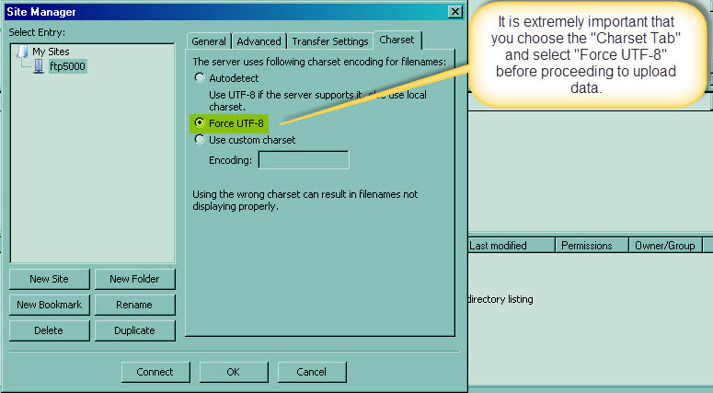Figure 2: UTF-8 Settings

Image Requirements

PERFERRED:
- No transparent PDF objects should be used for art or layout.
- No transparent PDF objects should be hidden behind other graphic objects
- Quality of the images should be sufficient to display at the recommended size (700 pixels wide) and resolution (150 dpi). See recommended format requirements for minimum and maximum values.

Font REQUIREMENTS

Required:
- All text must be represented in the document in full, with no placeholders, in order for the PDF to be full-text searchable on the Flipster platform.
- For processing only, all text must be available for search, and copy and paste.
  - Note: Restrictions will be added to content on product.
- Do not use custom fonts because they can contain unsupported encoding.
  - Supported fonts include: Western Latin 1252 (Western European) and Unicode 8 character entities.
  - The Standard Base 14 fonts, supplied with the Adobe Reader can be handled through font emulation.
- Embed all fonts as complete sets. This is the only way to guarantee that the text will display as intended for every end-user. Subset fonts, while acceptable, limit the editing capabilities within the PDF.
- To embed your fonts, follow these steps in Adobe Acrobat Pro:
- Open Acrobat Distiller. (Advanced>Print Production>Acrobat Distiller)
Click Settings.
- Click “Edit Adobe PDF Settings”
- Match your settings for all of the categories .
When complete click “Save As…” and save the settings as nlStandard.

Multimedia
We do not currently accept multimedia content.

EDITION REQUIREMENTS

Required:
- National Edition of the publication is required (i.e. not the regional versions).

Appendix

Adobe PDF Settings
Create your source documents using standard fonts and standard Western European encoding. Avoid using custom fonts and/or custom encoding as they can make your text unsearchable online. To test your text for searchability, perform a simple copy/paste to Notepad or any text editor. The text you selected should be displayed in full. See Figures 3-8.
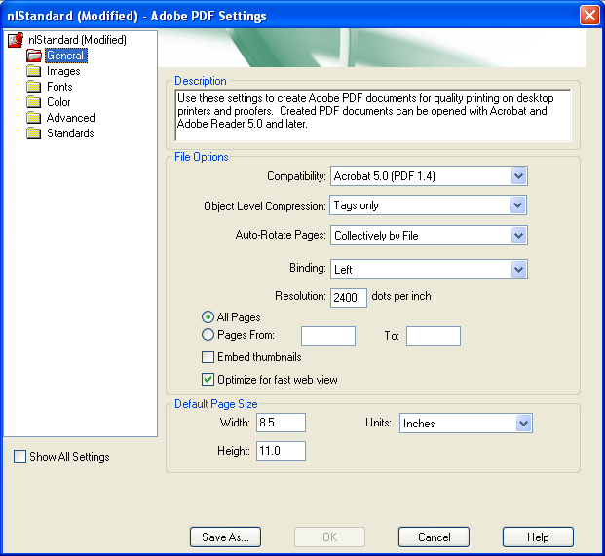 Figure 3: PDF Specification

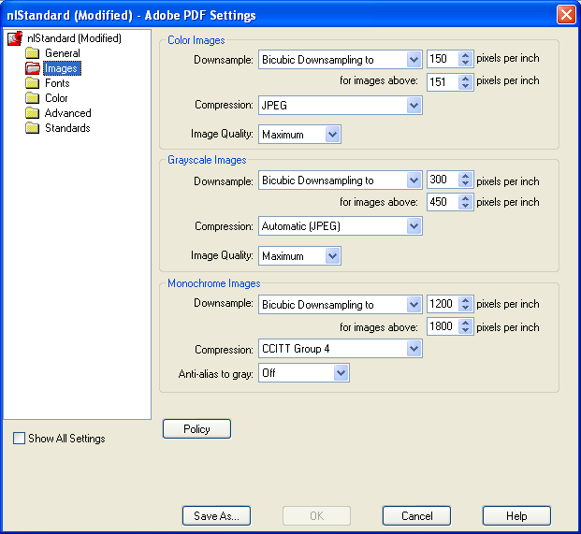 Figure 4: Images

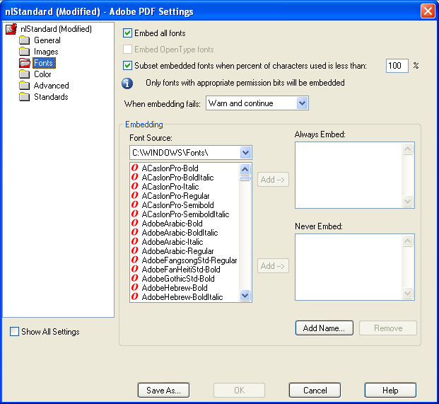 Figure 5: Fonts
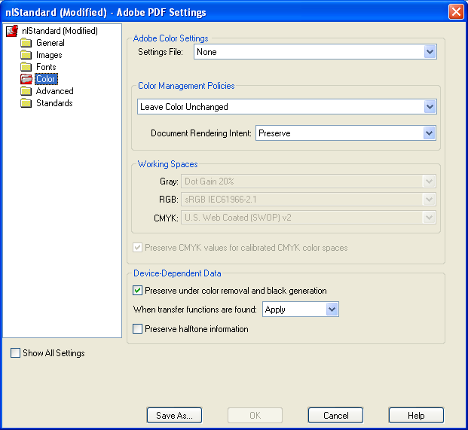 Figure 6: Color
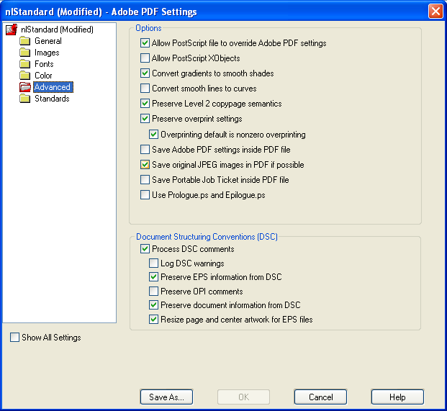 Figure 7: Advanced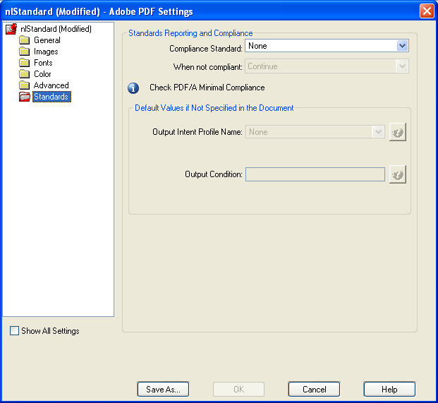 Figure 8: Standards

