EBSCO eBook Content & Delivery - Guidelines in Brief

When to deliver files
- Send metadata and content pre-publication. We respect on-sale dates and embargos.
More detail about when to deliver on page 2

How to deliver files
- Deliver via FTP. We'll supply you with unique FTP credentials.
More detail about how to deliver on page 2

What files to deliver
- EPUB and/or PDF: both formats are preferred.
- EPUB2 and EPUB3, but some elements of EPUB3 are not supported at this time
- The ebook file must contain at least 3 bookmarks.
- Digital pagination must match content pagination.
- ebook files must have a cover
- PDF files should be web-ready and accessible.
- PDF files must have embedded text.
- File naming: Name all content files using the eISBN
- Metadata files are required. Two kinds are accepted:
  - ONIX 2.1 according to industry standards
  - EBSCO's Excel metadata spreadsheet template (MDSS) - must include all required fields.
- Modifications to price, availability, etc: resubmit metadata files with updated information
  - ONIX 2.1 publishers may reactivate/deactivate via metadata refreshes
  - If using MDSS, reactivation requests must be emailed. Delivering updated metadata will not activate inactive titles.
More detail about what to deliver on page 3

EBSCO eBook Content & Delivery - Full Guidelines

When to Deliver
Please send all of your content as soon as it's available, prior to the on-sale date.
We prefer that you send content with the corresponding metadata at the same time. You may also send metadata ahead of content. Please do not send content ahead of metadata.

On-Sale Dates/Embargos
If you specify an on-sale date in your metadata, EBSCO will not allow your ebook to be sold prior to this date. If your agreement with EBSCO includes embargos on certain models, our systems will not place your book for sale for those models until the embargo has ended.
Please deliver your books as early as possible so that we can process your content and have it ready to go up on product as soon as it should be available for sale. If you wait until after the on-sale date or embargo date, it's possible the content could encounter production problems that delay its placement on product, and thus delays usage or sales.

How to Deliver
Please deliver your ebooks via EBSCO's FTP. We will supply you with credentials during the licensing and onboarding process.
If you lose your credentials, please email publishercm-ebooks@ebsco.com.
We can also retrieve data from an FTP location. It must be a consistent location (i.e. we cannot retrieve from a different location for each delivery). Arrangements can be made by emailing publishercm-ebooks.com.

File Structure
All files for every title should be delivered together in the same folder. Please do not deliver compressed folders (.ZIP, .RAR, etc).
For publishers with multiple, contractual imprints, all files should be sorted into folders labeled with the imprint name.
Example:
- Imprint A
  - 9781234567891.epub
  - 9781234567891.pdf
  - 9781234567892.epub
  - 9781234567892.pdf
- Imprint B
  - 9781234567893.epub
  - 9781234567893.pdf
  - 9781234567894.epub
  - 9781234567894.pdf

FTP
You can connect to the FTP using any FTP client and your credentials.

How to use the FTP
For detailed instructions on how to use FileZilla, a free FTP client, to access the FTP please refer to the detailed instructions in the appendix of this document on page 12. We recommend you review these instructions if you are not familiar with FTPs.

What to Deliver

Titles
Please deliver, at minimum, all titles that you deliver to other sales platforms, unless your licensing agreement specifies otherwise.

File Formats
EBSCO accepts two file formats for ebooks:
- EPUB
- PDF
We prefer for each title to be available in both EPUB and PDF, as this creates the best experience for users. Therefore, if you have both formats, please supply them. When both formats are delivered, EBSCO will bundle them into one sellable unit. Please see ONIX metadata documentation on page 8 for more detail on how this will impact your metadata creation.
We will also accept whichever single format you have available, EPUB or PDF.
Generally, EBSCO accepts PDFs and EPUB files that are created according to standard publishing and accessibility guidelines.
EBSCO does have some requirements and recommendations that are unique to EBSCO and may not be required for other sales platforms. We have extensively researched library customer needs and these additional requirements result in a higher quality user experience.
We have also provided guidance to help prevent common errors that would make files invalid on any platform.

Accessibility
EBSCO is committed to providing accessible content for our mutual customers, and we recommend content that is accessible according to WCAG 2.0 guidelines.
For a detailed overview of best practices for creating accessible eBooks, please refer to EBSCO's guide in the appendix of this document, on page 15.

Cover & Images
- All images used in PDF or EPUB files should be in RGB mode, not CMYK.
- Please do not convey tables/charts or text as images: use tables or text.
- The cover image should always be the first page in the eBook. The back cover may be included but is not required.
- Must be either in .JPG, .PNG, .TIFF, or .EPS format.
- Minimum size is 400 pixels and 72 ppi resolution. Maximum size is 700 pixels and 150 ppi resolution.
- If you do not have cover image rights for a title, you may create your own generic cover containing the title and author of the book.
- If a title is delivered without a cover image, EBSCO will create our own generic cover for your book.
We highly recommend you provide a cover as it improves saleability of the book.

EPUB Checklist
Please check the following before submitting files.

Basic EBSCO EPUB guidelines
- NCX navPoint should NOT have missing/non-sequential playOrder values
- Cover file is included and has a <playOrder> value of 1 in the .ncx file
- No Javascript.
- Text should respond to eReader resize commands: ensure all font-size values in the CSS file are expressed in ems or percentages
- Graphs and charts should be created in tables so the content resizes and reflows
- "Figure" and "Figcaption" elements are used to provide alternate text that conveys the same information as the image

Run your file through a standard validation engine and ensure you correct any of the following errors
- Nested A Element errors: links cannot be buried inside other links
- Referenced Resource errors: code contains references to objects the validator can't locate
- CSS Parsing errors
- Cover Display errors: should resize to fit eReader
- Invalid .ncx IDs
- EPUB Page Numbers

EPUB Page Numbers
EBSCOhost's eBook viewer will display EPUB page numbers that correspond to the print/PDF version of the eBook if pagebreak elements are used appropriately, according to EPUB standards.
These 2 elements must be present within a <span> tag:
- epub:type="pagebreak”
- title="page#"
Example for page 63 of a book:
<span epub:type="pagebreak" id="page63" title="63"/>
For more detail on how to use pagebreaks please refer to IDPF documentation.

Unsupported Elements of EPUB3
At this time, some elements of EPUB3 are not supported. Please either send a backwards compatible file (for example a version of the EPUB without video or audio) or send your files as is and we will place it on product when the element can be supported.
- Audio & Video
- MathML
- Media Overlays
- Top Bottom Right Left text rendering

Backwards Compatibility
For more information on industry standard recommendations to make backwards compatible files, please refer to IDPF's guide: http://www.idpf.org/epub/30/spec/epub30-changes.html

PDF Checklist
- Text must be embedded and available for search and copy and paste. If all or part of your PDF was created from hardcopy scans, you must capture the text using an OCR program.
- All fonts should be embedded as complete sets.
  - Use supported fonts: Supported fonts include Western Latin 1252, Unicode 8 character entities, and the Standard Base 14 fonts. Do not use custom fonts.
  - Fonts must use standard encoding. Custom encoding will not allow for text to be searched.
- Cover image should be the first page of the PDF.
- Files must be free of encryption, password protection, or any security features applied in Adobe Acrobat
- Digital Pagination must match content pagination
  - Non-standard page numbering, such as chapter 1 page 2 being represented as "1.2," must match for optimal user experience.
  - Every page must be labeled, and every label must be unique. Multi-volume books should include a volume number followed by a hyphen and then a page number so that there are not multiple page 1s, etc.
  - Use a hyphen in pagination, if needed. Do not use em or en dashes in pagination.
  - Blank pages may be labeled "Blank-1" etc if they are not included in the pagination of the original book. Do not remove blank pages which ARE part of the book's pagination.
- Include at least 1 bookmark, although more are preferable
  - We strongly recommend bookmarks for front matter pages and each section or chapter.
  - Bookmarks must match the content of the original book's table of contents, including special characters.
  - Some non-English language books position their table of contents at the end of the book. This positioning should be retained in the bookmarks.
- The electronic table of contents (eTOC) should mirror the original book's table of contents, match any parent-child hierarchies, and not exceed three nested levels deep.
- Pages must be cropped and free of registration and/or printer marks. We recommend cropping pages uniformly through the document, with text on both even and odd pages centered on the page.
- Any full-page landscape pages (such as maps and graphs) must be rotated horizontally for left to right reading.
- File sizes: all files must be optimized for the web to be as small as possible. Best practice for individual pages is to have a file size that is smaller than 200 KB.

Omitted Content
To provide the best user experience, please include disclaimers for omitted text and/or images. The following are examples of standard disclaimers:
- "This page is intentionally left blank."
- "Some pages/text in the printed version of the book are not available for the electronic version."
- "This eBook does not include ancillary media which was included in the print version."

Metadata
Metadata must be submitted for every eBook. We accept metadata formats:
- ONIX 2.1 (we do not currently support ONIX 3)
  - Learn more about EBSCO-specific guidelines for ONIX 2.1 on page 8
- MDSS (EBSCO's Metadata Spreadsheet Template)
  - Download EBSCO’s MDSS template – column headers include instructions on how to fill out the template.
  - Only the fields that are in the spreadsheet are able to be ingested. The MDSS does not allow for as much complexity as ONIX metadata. For publishers that would like to enhance their metadata but are unable to create their own ONIX feed, we suggest looking into distributor relationships that create ONIX as a value-added service.

File Naming
Please label each content file with the electronic ISBN. Do not include any additional text, such as the title of the book.
Example
- 9781234567890.epub
- 9781234567890.pdf

Replacement file naming
If you're providing a replacement for a file that has previously been sent to EBSCO, please add "_replacement" to the file name.
Example
- 9781234567890_replacement.epub
- 9781234567890_replacement.pdf

Metadata file naming
Metadata files (ONIX or MDSS) should include the publisher name and date of distribution. It is helpful to identify what "type" of feed you are sending:
- Delta: all new and updated records together
- Withdrawal: if you are not leveraging the ONIX PublishingStatus field
- Full Catalog Refresh: only upon EBSCO's request, or sent quarterly or less frequently
Example
- PublisherName_delta_yyyymmdd.xml
- PublisherName_withdrawal_yyyymmdd.xlsx

Modifications and Revisions
Modifications and revisions can happen at any time. Always send revisions through your metadata files or by uploading a new content file:
- Revised content file: send the updated file to the FTP as usual, using the replacement file naming structure on page 6.
- Revised metadata: examples include changing the price or you'd like to remove a title from sale. Please refer to the metadata guidelines on page 8.

Appendix

ONIX 2.1 Guidelines

ONIX 2.1 Standard
Please prepare your ONIX 2.1 feed using EDItEUR’s ONIX for Books Codelists. EBSCO eBooks does not yet support ONIX 3.0.
If you would like a more thorough overview of best practices, we recommend downloading Book Industry Study Group and BookNet Canada’s free resource, “Best Practices for Product Metadata: Guide for North American Data Senders and Receivers (June 1, 2015).”
The guidelines in this document highlight some commonly misused elements of the standard as well as guidelines that are required for EBSCO delivery but may only be recommendations or options in the standard.
For more detail on any of these requirements, please refer to EDItEUR’s ONIX Books Product 2.1 Revision 03.

File Preparation
We prefer for all titles in the feed to be packaged in a single .XML file rather than multiple single-title .XML files.
All the records in an ONIX file will be processed under the same contract. Therefore, titles from different publishers or imprints with distinct agreements and royalty reports should be submitted in unique ONIX files.

Order
It is important for your ONIX code to follow the correct order. Your ONIX file must adhere to the schema outlined by EDItEUR for ONIX 2.1.

PR.1.1 – Record Reference Number
Every product in your ONIX file must contain a unique Record Reference number.
Reference name: <RecordReference>
Short tag: <a001>
Example: 8474339790

PR.2.7, PR.2.9 – Product Identifier Types and Values
Product Identifiers must be eISBNs.
Reference name: <ProductIDType>
Short tag: <b221>
Required value: 15 (ISBN-13)
Reference name: <IDValue>
Short tag: <b244>
Required value: eISBN-13 value

PR.3.1 – Product Form Code
EBSCO can only accept ONIX records with the <ProductForm> short code “DG” – if records with other product forms are received (such as the record for the book’s hardcover version), it could prevent the successful ingestion of “DG” records.

PR.14.13 – Complexity scheme identifier
Some K-12 publishers may leverage a Lexile measure. Please follow the ONIX 2.1 standard for Lexile measure using the Complexity composite, NOT the Audience composite.
Please see List 32, “06”: “The Lexile measure in <ComplexityCode> combines the Lexile number (for example 620L or 880L) and optionally the Lexile code (for example AD or HL). Examples might be ‘880L’, ‘AD0L’ or ‘HL600L’.”
Note: In earlier versions of ONIX the Lexile code/measure was listed in the Audience composite, however this usage is deprecated and will not be captured in EBSCO’s ingestion of your ONIX feed.
Reference name: <ComplexitySchemeIdentifier>
Short tag: <b077>
Example: HL600L

PR.20 – Publishing Status Composite
Publishing Status (PR.20.1) is a required field. EBSCO is able to process withdrawals and activations based on the values in this composite.
Active Codes
00: Unspecified
02: Forthcoming
04: Active
09: Unknown
Inactive Codes
01: Cancelled
03: Postponed indefinitely
05: No longer our product
06: Out of stock indefinitely
07: Out of print
08: Inactive
10: Remaindered
11: Withdrawn from sale
12: Recalled (deprecated code)
15: Recalled
16: Temporarily withdrawn from sale
17: Permanently withdrawn from sale

PR.21.1 – 3 Sales Rights Composite
You may transmit sales rights information by defining ALL countries/territories where you:
- have the rights to sell the eBook (<SalesRightsType> 01–02)
OR
- do NOT have the rights to sell the eBook (<SalesRightsType> 03–06)
If you would like to define both includes and excludes, you must give a full accounting of all countries/territories: the whole world must be represented.
Any deprecated country/territory codes will cause an error.
PR.21.1
Reference name: <SalesRightsType>
Short tag: <b089>
Accepted value range: 01–06
PR.21.2
Reference name: <RightsCountry>
Short tag: <b090>
Example: US CA AU
PR.21.3
Reference name: <RightsTerritory>
Short tag: <b388>
Example: WORLD or ROW

PR.23.7, PR.23.10, PR.23.12 – Related Product Composite
Any alternate versions of the same work (such as the corresponding print edition or additional ebook format) must be identified by their unique 13-digit ISBN. Print counterparts must be identified with RelationCode 13. “Born digital” ebooks must refer to alternate electronic manifestations using RelationCode 06. Products that are related to the work, but not the same (such as other volumes in a series) must not use RelationCode 13 or 06.
PR.23.7
Reference Name: <RelationCode>
Short code: <h208>
Required values: 13 or 06

PR.24.49–75 – Price Composite
EBSCO eBooks can accept exactly one price value <PriceAmount> per currency <CurrencyCode> per title. This must be the price most appropriate for EBSCO’s customers and will serve as the base price (single user purchase model) for all of the title’s available formats (corresponding PDFs and EPUBs are sold together, not individually).
The price cannot be zero.
Currently, EBSCO can support pricing in USD and GBP.
Changes to pricing: Submit a new “delta” record, which will overwrite the existing record with the new price.
<SupplierName> and <ProductAvailability> fields are required. We strongly suggest using the <OnSaleDate> field, particularly if embargos apply.
Reference name: <PriceAmount>
Short tag: <j151>
Example: 189.99
Reference name: <CurrencyCode>
Short tag: <j152>
Example: USD
Reference name: <SupplierName>
Short tag: <j137>
Example: YourName Publishers
Reference name: <ProductAvailability>
Short tag: <j396>
Example: 20
Reference name: <OnSaleDate>
Short tag: <j143>
Example: 20180101

FTP Detailed Instructions – for EBSCO eBook delivery
These detailed instructions will walk you through the process of delivering your content to EBSCO via FTP, which stands for File Transfer Protocol, on your Mac or PC using the FileZilla FTP client.
First, if you do not already have it, download the FileZilla FTP client for free from https://FileZilla-project.org. FileZilla is a popular FTP client that works on all computer platforms.
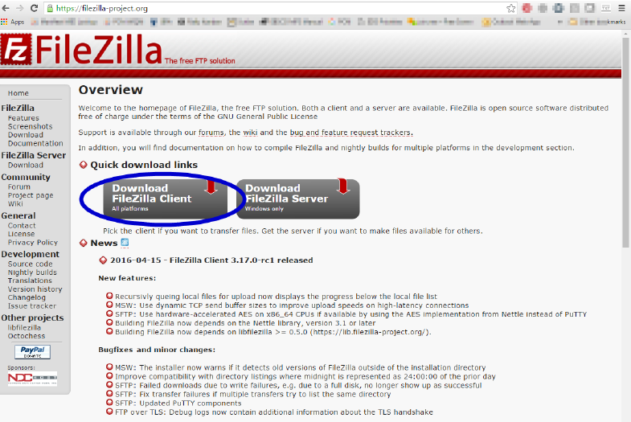
After downloading FileZilla, open up the FileZilla application.
In the Host field at the top of the window, type the host name provided in your onboarding materials.
Then enter your unique Username and Password that was provided to you by your eBook Publisher Content Management Specialist.
Leave the Port field blank.
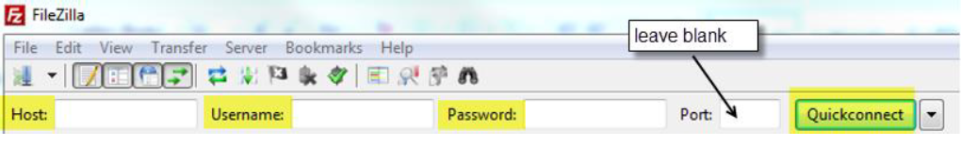
If you are in need of an FTP account, or if you have any trouble logging in, please email the eBook PCM team at publishercm-ebooks@ebsco.com.
Click Quickconnect (or Enter) to connect to the FTP server.
Once you are connected, you will see your local files on the left side and the FTP server files (or empty folder, if nothing has been uploaded yet) on the right. In the box containing your local file directory, highlighted in green below, navigate to (double click on) the folder where your content files are located.
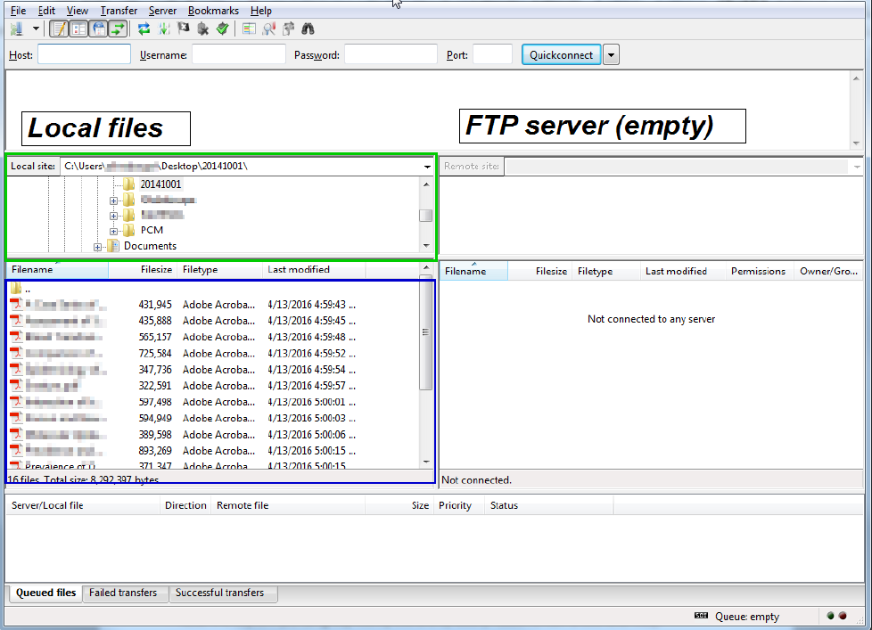
When you select a folder within the local site (highlighted in green) the files within that local folder will display in the lower left box (highlighted in blue). In this example, the desktop folder named “20141001” is highlighted and the blue highlighted box shows all the files within “20141001.”
Select all the files you wish to transfer (hold Ctrl and click the files you need, or to select all files in the folder, hold Ctrl + a) and then drag the selected files across to the lower right quadrant, which will copy them onto the FTP server.
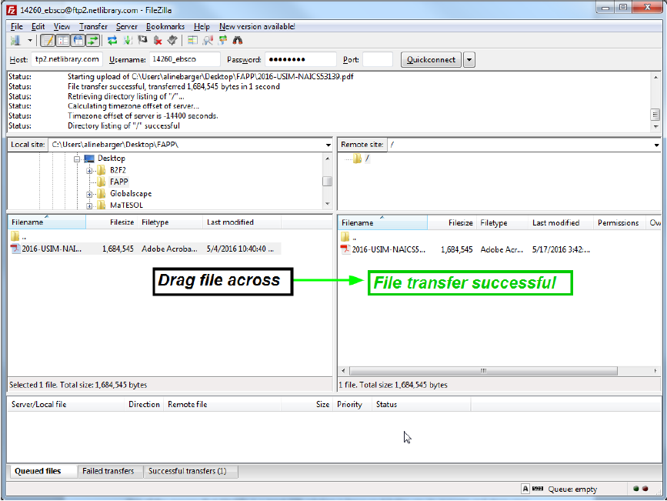
Once your files are fully copied to the folder, you have successfully delivered to EBSCO. To log out, simply close the browser

Note:
- Content file naming conventions – all files should be named by eISBN.
More information about file naming conventions on page 6.
More information about recommended folder structure on page 2.
- Our FTP system for eBooks mirrors content every hour to our production platform for processing. So don’t worry if you see files quickly “disappear” from your FTP view.

Helpful Tips:
- One of the reasons that FileZilla is a great FTP solution is because it helps you to manage and store your FTP accounts and password info.
- To save your login information for future use, go to “File – Copy Current Connection to Site Manager”. The below pop-up window will appear.

Publisher Best Practices for Creating Accessible E-Books
Following are guidelines and best practices to ensure optimal use and accessibility of your content. These guidelines follow the Web Content Accessibility Guidelines 2.0. More information and examples can be found at WCAG 1.3.1 Content Structure Resources
In general, efficient navigation is difficult for visually impaired users if the document is in plain text and not tagged. Tagging appropriately conveys a document’s structure and semantics back to users so that they can navigate and consult the resource. Additionally, EPUB affords much greater accessibility for users, so EBSCO encourages all publishers to send titles in EPUB format whenever possible.
It is important that in both PDF and EPUB, images have alternative text, figures have accessible captions and tables have proper semantic table markup. There are two critical use cases to keep in mind when developing alternative text and captions for images and figures.
First, it is important that blind users know that there is an image or figure in the content they are using and what that image or figure shows or conveys. The screen reader should say, “Following is an image of ___.” If there is no alternative text, a blind user would not know there was any additional content.
Secondly, EPUB allows images and figures to be searchable when a user performs a search within the content. If the alternative text is appropriate, any relevant images should appear in the user’s search results. Tables can be a particular challenge for accessibility. Rows and columns must be associated with relevant headers to provide context for data. In general, simpler tables are more accessible.
Below are more detailed guidelines for creating accessible and usable content for our shared users.

PDF Content
- Use semantic tags to convey the document structure clearly. In particular, use tags for headings, paragraphs, lists and tables. Semantic elements such as <p> and <h1>…<h6> can be used to convey the document structure to screen reader users. For more information, see WCAG 1.3.1 A and the following pages for more information:
  - https://helpx.adobe.com/acrobat/using/editing-document-structure-content-tags.html#standard_pdf_tags
  - https://www.w3.org/TR/UNDERSTANDING-WCAG20/content-structure-separation-programmatic.html
  - PDF6: Using table elements for table markup in PDF Documents
  - PDF9: Providing headings by marking content with heading tags in PDF documents
  - PDF17: Specifying consistent page numbering for PDF documents
  - PDF21: Using List tags for lists in PDF documents
- Avoid over-using non-semantic tags, or tags that do not convey structural information and are used as generic groupings, such as <div> and <span>.
- Avoid breaking up individual words and sentences with tags.
- Use consistent page numbering throughout the document. Other notes:
  - PDF17: Specifying consistent page numbering for PDF documents

EPUB Content (Desktop)
Navigation and Structure: Information added using CSS is not passed to screen readers, making the content inaccessible. Use HTML semantic elements according the W3C code specifications.
- Include semantic elements in EPUB documents, such as headings.
- Avoid using non-semantic elements such as <div> and <span>.
- Avoid using hidden elements in CSS when possible.
- See WCAG 1.3.1 A for more information https:/www.w3.org/TR/UNDERSTANDING-WCAG20/content-structure-separation-programmatic.html%20

Images, Tables, and Figures:
- Utilize the “Figure” and “Figcaption” elements to provide a description, caption, or alternate text for any images and avoid referring to them by their place on the page (e.g. “in the figure at left”)
- Make sure the alt-text conveys the same information as the image. See 1194.22 A and 1.1.1 A for more information.
  - https://section508.gov/content/quick-reference-guide#1194.22d
  - https://www.w3.org/TR/2012/NOTE-UNDERSTANDING-WCAG20-20120103/text-equiv-all.html
- Use images only for pictures, not for tables or text. Use proper and complete markup tor table data http://diagramcenter.org/59-image-guidelines-for-epub-3.html
Other information about EPUB accessibility can be found on the IDPF site: https://idpf.github.io/a11y-guidelines/

EPUB Pagination
It is critical to have stable pagination (that corresponds to the print and/or PDF version of the work) in order for researchers to generate proper citations. EBSCO has built support of EPUB pagination into the EBSCO eBook viewer, so that the EPUB format can be used and cited by all users. Please ensure your EPUB files have pagination according to the IDPF https://idpf.github.io/a11y-guidelines/content/xhtml/pagenum.html
- Information such as page number should be conveyed consistently via HTML so that it is accessible to screen readers.
- Add visually hidden text such as "Page" so when the screen reader user gets to the "3" they will hear "Page 3". See 1194.22 d and 1.3.1 A for more information
  - https://section508.gov/content/quick-reference-guide#1194.22d

Other Suggestions to Optimize EPUB for General Usability
EBSCO has built an online viewer that allows users to display EPUB content in a web browser. This provides an opportunity for publishers to:
- Tag end-of-chapter references and the reference pages with IDs and use anchors to link between the two so that the user can return to the referencing page and continue reading
- Tag all references to Chapters or Section headings
- Provide complete navigation by always using the structural semantics vocabulary governed by the IDPF http://www.idpf.org/epub/vocab/structure/
- Follow guidelines for ARIA landmarks http://www.w3.org/WAI/GL/wiki/Using_ARIA_landmarks_to_identify_regions_of_a_page

